User Manual

**Project Name:** Drone Traffic Simulation

**Course:** CASE4

**Module Title:** CA Final Year Project

**Module Code:** CA400

**Student Name:** Jack Murphy (13436498)

**Supervisor Name:** Prof. Alan Smeaton

**Submission Date:** 22/05/2017

# Table of Contents

**No table of contents entries found.**

# Introduction

My project is to create a simulation of Drone Traffic in a city scape. The simulation is designed to be run and operated by a single individual from a coding perspective. Thus, there is minimal interaction from the user perspective. However, there several operations the user can carry out and the users’ experience is mainly from a viewing stand point. The results of the simulation are not affected by the interaction of the users. In this manual, I will also include a plan for installing the system, on another device. Which would require hosting my SQL Server on an online resource. I will outline how this might be achieved also.

# Installation Guide

This simulation was built to run on Windows. The simulation can run locally and on a server. To set this up on a locally there several steps as follows:

1. Install Visual Studio locally
   * Various free editions available or through DCU DreamSpark
2. Install Xenko Game Engine from the website
   * <http://xenko.com/>
3. Install SQL Server Management Studio from
   * <https://docs.microsoft.com/en-us/sql/ssms/download-sql-server-management-studio-ssms>
4. Install SQL Express to allow you to run SQL Studio
   * <https://www.microsoft.com/en-us/sql-server/sql-server-editions-express>
5. Once this has complete, create a Database called DroneTrafficSimulation
6. Clone project repository on local Windows environment
7. Create the tables using the script supplied in the repository
8. Open Visual Studio and load the solution using the solution files in the repository
9. In Visual Studio edit the config files to update the connection string
10. Once this is done the initial setup has been completed and the project can be run

To set this up on a server, I would do the following:

1. First I would find a suitable host for my SQL Server
2. Then I would install the SQL Server onto this server
3. Once the server has been set up to host the SQL Server, I could run the script to create the tables in the database
4. Once the tables have been created I would update the Application Config files accordingly

There would be many benefits to hosting this server online, however for the purposes of this simulation it would not be necessary as it only needs to be run locally on my machine.

# Running the Simulation

To run the simulation there are a number of steps to follows:

1. To start the simulation, in Visual Studio press the start button at the top of the screen



1. Once the simulation is running you will be greeted with this screen

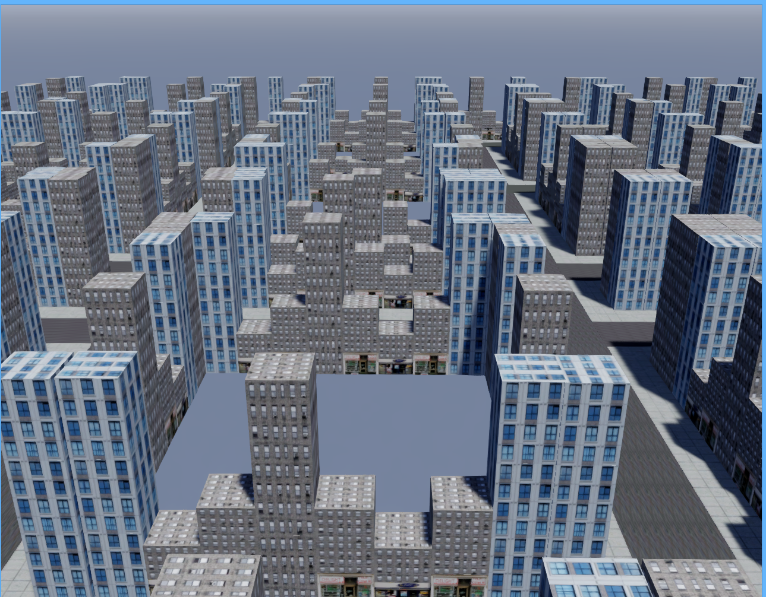

1. You will be able to manoeuvre through this world using a combination of the mouse and the UP, DOWN, LEFT and RIGHT keys
2. To navigate with the camera, move the mouse so the view is looking in the direction you wish to go.
3. Then to go forward from where the camera is pointed use the UP key.
4. To go backwards press the DOWN key.
5. To move left or right press the LEFT or RIGHT keys respectively.

These steps encompass all that is available to the user. The drones can be view generating randomly and navigating though the world.